**Math 120  
2.2 Models and Applications**

# **Objectives:**

1. Use linear equations to solve problems

# **Topic #1: Modeling and Applications with Linear Equations**

When solving linear equations in context (word problems), we are often responsible for coming up with an equation for a given situation, and need to translate the words of the problem into algebra.

**Here is the basic strategy:**

1. Read the problem carefully (2-3x) and identify all quantities. Assign a ___________________ to the unknown quantities.

2. Write expressions for any unknown quantities in terms of your assigned variable.

3. Write an equation in your variable that models the problem.

4. Solve the equation and *________________________________________*

5. Check the solution to see that *________________________________________* not just in the equation.

# ***Example #1* – Construct and Solve the Linear Equation**

According to market research, the average cost of a new car in 2014 was $37,600. Every year after 2014, the average cost of a new car is expected to increase by about $1250 per year. Assume that this trend will continue for many years.

Let x be:

Let C(x) be:

a. Write a function that models the average cost of a new car years after 2014.

This is a linear model.

The slope of the line is the rate of change___________

y-intercept is the initial value______________________

Using slope-intercept form:

b. In how many years after 2014 will the average price of a new car cost $48,850?

This is asking when ___________________________

Interpret your answer in a sentence. **Does your answer make sense?**

c. Graph the solution to part b.

Let the left side of the equation be and the right side be .

To view the graph, the window will need adjusting. Here, we know x and y must both be positive. Moreover, the y maximum needs to be at least 48850 to see the second line.

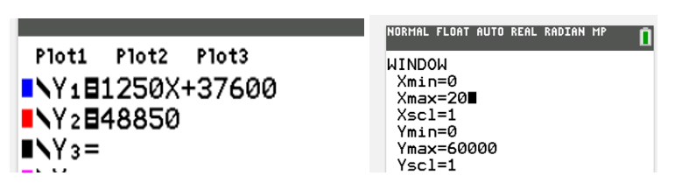

The intersection of the lines is the solution:

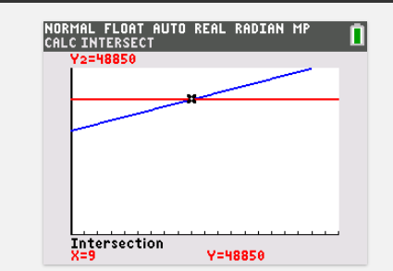

***Example #2* – Construct and Solve the Linear Equation**

In 2020, there were 12,200 students at college A, with a projected enrollment increase of 1000 students per year. In the same year, there were 24,200 students at college B, with a projected enrollment decreaseof 500 students per year.

Let x be:

a. Write a function that models enrollment years after 2020 for college A.

b. Write a function that models enrollment years after 2020 for college B.

c. Based on the projections, when will the colleges have the same enrollment? What will the enrollment be at that time?

d. Use the table to confirm the solution.

What equations are entered for and

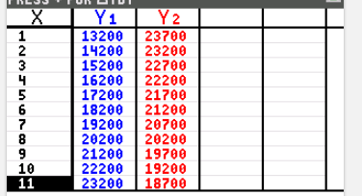

The table confirms both values are equivalent when

Moreover, the table shows those values are both ____________________

**Does your answer make sense?**

# ***Example #3* – Construct and Solve the Linear Equation**

After a 35% reduction, a person purchases a guitar for $780. What was the original price of the guitar?

Let .

There is a discount of 35%, which means the person is only paying ________________________

The equation says “65% of the original price is $780”

**Does your answer make sense?**

***Example #4* – Construct and Solve the Linear Equation**

Including a 7% sales tax, a hotel charges $235.40 per night for a room. Find the cost of the room *before* taxes.

Let

There is a tax of 7%, which means the hotel is adding 7% to 100% of the original cost.

In words, the hotel is charging ___________________ of the original price for the room. This is equal to the total cost of ___________________

The equation says

“107% of the original price is $235.40”?

**Does your answer make sense?**

# ***Example #5* – Construct and Solve the Linear Equation**

The length of a rectangular pool is 6 meters less than twice the width. If the perimeter of the pool is 126 meters, what are its dimensions?

There are two unknown quantities, the length and width of the pool.

Since the relationship between the quantities is given, we have an equation:

Let length =

Let width =

The known quantity is the perimeter, . Using the formula for perimeter, we have another equation:

This tells us the width is **_______________**

The length is 6 less than double the width ___________

**Does your answer make sense?**

***Example #6* – Construct and Solve the Linear Equation**

Three friends discuss their hourly wage. The first friend makes double the second friend and the third friend makes $5 more per hour than the second friend. If the combined hourly wage of the friends is $49 per hour, find how much each friend makes per hour.

There are three unknown quantities, the wages of the 1st friend, 2nd friend, and 3rd friend.

The known quantity is the sum of the wages, ________

This gives the equation:

This tells us the 2nd friend makes_______________

The 1st friend makes_________________

The 3rd friend makes _________________

We can confirm the values are correct by adding up the wages______________________________

***YOU TRY #1* –** Does it make sense?

a. The projected enrollment, y, of a college where there were 25,000 students decreasing at a rateof 500 students per year, x, can be modeled by y=500x+25,000.

b. According to market research, the average cost of a new car in 2014 was $37,600. Every year after 2014, the average cost of a new car is expected to increase by about $1250 per year. For the year 2025 the new cost of the car will be $39,000.

c. After a 35% reduction, a computer’s price is $780, so I determined the original price, *x*, by solving

d. I should check my answer with the original wording of the problem and not the equation I constructed in case I made a mistake and my equation doesn’t model the problem.

***YOU TRY #2*** – Construct and solve the linear equations

a. In 2014, the average price of a new car was $37,600. New car prices increased by approximately $1250 per year. Write an equation modeling this situation. If this trend continues, how many years after 2014 will the price of the car average $46,350? In which year will this occur.

b.

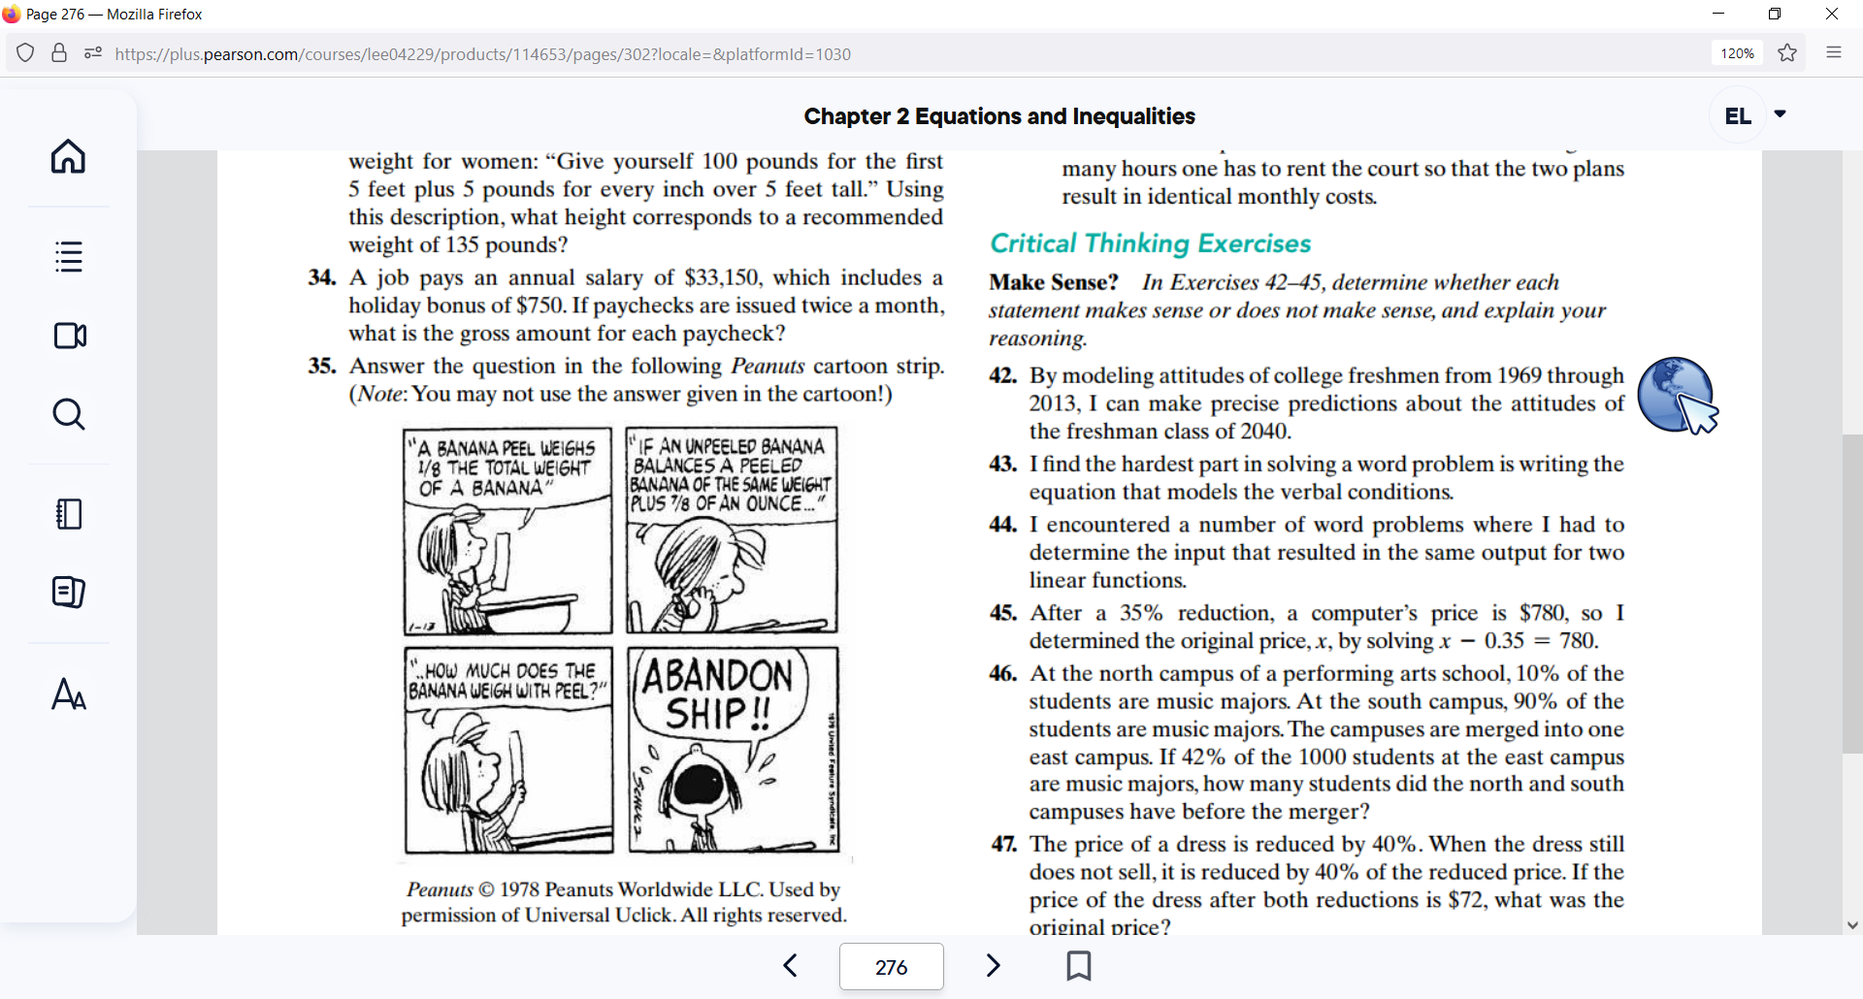

c. The length of the rectangular tennis court at Wimbledon is 6 feet longer than twice the width. If the court’s perimeter is 228 feet, what are the court’s dimensions?